Create a React Application named “cricketapp” with the following components:
- ListofPlayers
  - Declare an array with 11 players and store details of their names and scores using the map feature of ES6
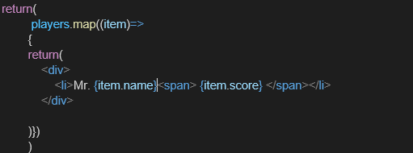

  - Filter the players with scores below 70 using arrow functions of ES6.
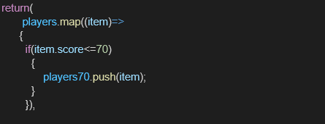

ListOfPlayers.js

import React from 'react';

function ListofPlayers() { const flag = true;

const players = [
{ name: "Jack", score: 50 },
{ name: "Michael", score: 70 },
{ name: "John", score: 40 },

{ name: "Ann", score: 61 },
{ name: "Elisabeth", score: 61 },
{ name: "Sachin", score: 95 },
{ name: "Dhoni", score: 100 },
{ name: "Virat", score: 84 },
{ name: "Jadeja", score: 64 },
{ name: "Raina", score: 75 },
{ name: "Rohit", score: 80 }
];

const playersBelow70 = players.filter(player => player.score <= 70);

return (
<div>
{flag && (
<>
<h2>List of Players</h2>
<ul>
{players.map((item, index) => (
<li key={index}>
Mr. {item.name} <span>{item.score}</span>
</li>
))}
</ul>

<h2>List of Players having Scores Less than 70</h2>
<ul>
{playersBelow70.map((item, index) => (
<li key={index}>
Mr. {item.name} <span>{item.score}</span>

</li>
))}
</ul>
</>
)}
</div>
);
}

export default ListofPlayers;

App.js

import React from 'react'; import './App.css';
import ListofPlayers from './ListofPlayers';

function App() { return (
<div className="App">
<h1>Welcome to Cricket App</h1>
<ListofPlayers />
</div>
);
}

export default App;

